

**Dentist Booking**

**Software Requirement Specification**

– HCM, July 2022 –

**Table of Contents**

I. Overview 3

1. Introduction 3

2. System Functions 4

# I. Overview

## 1. Introduction

Many customers, and dentists have requested a system that would help them manage their appointments remotely. On the customers' side, they want to make and view their appointments which include the service, dentist and time. On the dentist's side, they also want to have something to help them remember all the appointment dates and times. Such a system will give flexibility to both customers and dentists. The future ability for customers to book appointments will make a wide range of choices available to them. The feedback system can help customers choose the right dentist and service for themselves. The admin also gets benefits from the system since it will provide him/her with automatic tools which assist him/her in managing the system. Doccure, a dentist booking system supply services that meet all the requirements above.

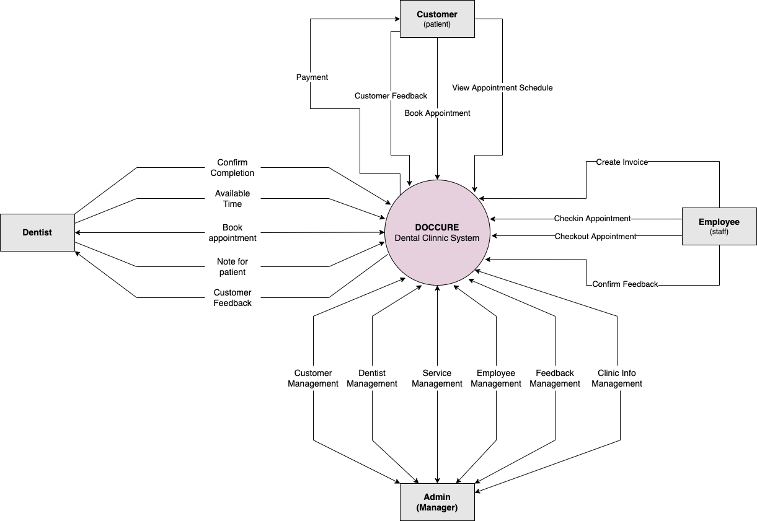

## 2. System Functions

#### a. Screen Flow

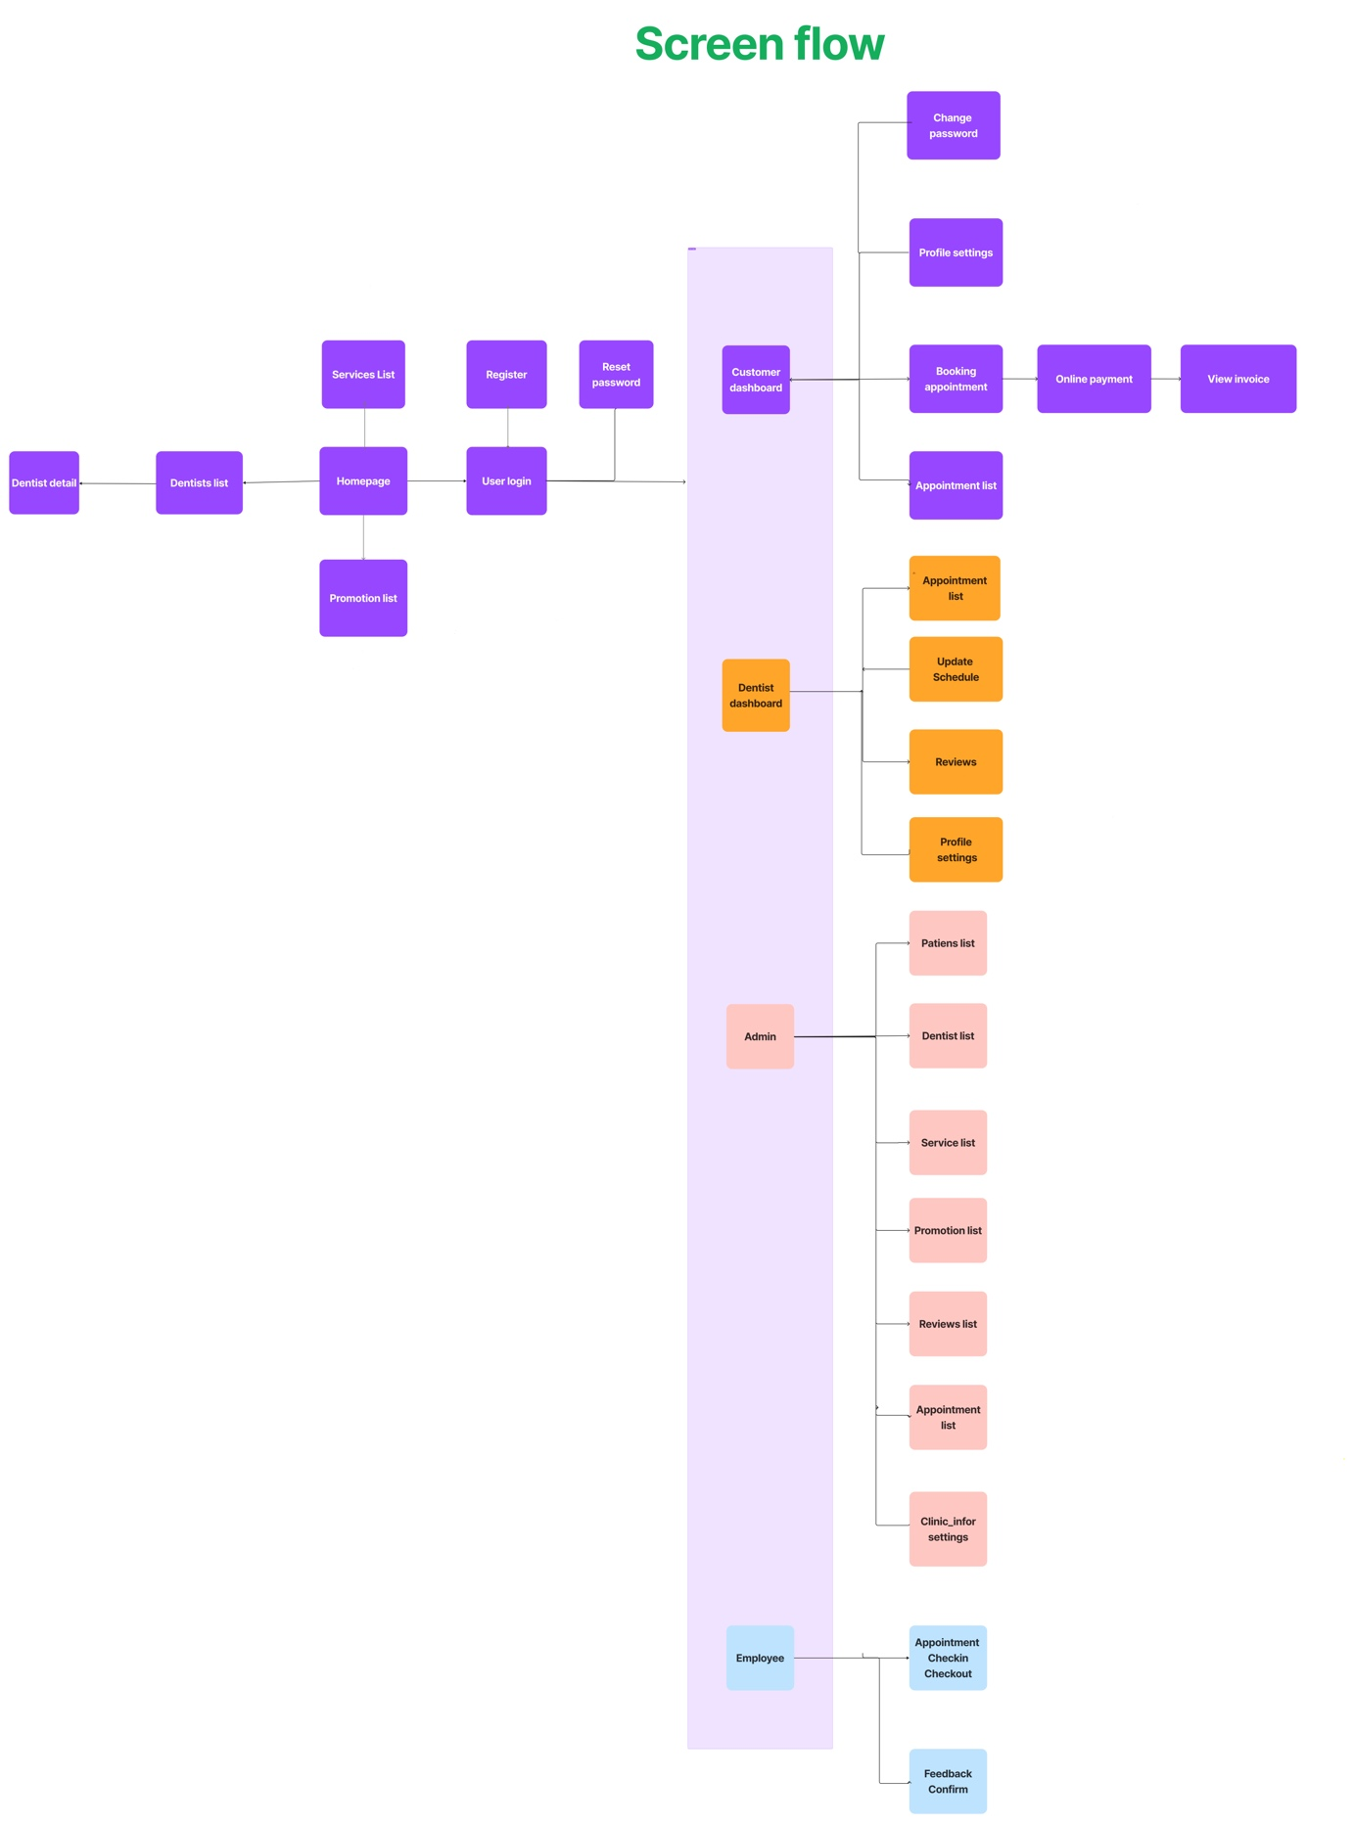

#### b. Screen Details

*[Provide the descriptions for the screens in the Screens Flow above]*

